Intro
- Wetlands are functionally unique inland waters, serving as global carbon sinks rather than carbon sources.
- Wetland emergent vegetation is highly productive, sequestering, and mineralizing CO2 while wetland soils- hydric and anoxic from the surficial aquifer- store litterfall, debris, and decaying organic matter (OM) for months to decades.
- The long residence of wetlands allows for significant carbon processing, and wetland hydric soils are known for significant emissions of GHG yet wetland storage potential and productivity offset carbon emissions.
- Wetlands serve as an intermediate between the terrestrial and the aquatic having the productivity of terrestrial landscape but maintain saturated conditions for the greater part of the year.

- Many wetlands have strong connectivity with streams, rivers, and lake. Specifically, riparian wetlands bridge lotic and terrestrial environments serving as the ecotone between terrestrial uplands and streams.
- Unlike more inland, depressional wetlands, all lateral exports from the catchment must bypass riparian wetlands before discharging to streams.
- Despite compromising 7% of the earth’s surface, riparian wetlands are hypothesized to have a disproportionate influence on the global carbon mass balance.
- Coined by Abril and Borge 2019 as “carbon pumps,” riparian wetlands possess significant potential for carbon storage and delivery with riparian groundwater and soil water having higher DOC and CO2 concentrations than stream water.
- Bernal et al 2022 found riparian groundwater had higher CO2 concentrations than stream water, and Ledesmda () predicts riparian wetlands are an inexhaustible source of stream carbon.
- From Marx et al. 2017. : Peter et al. 2014 found pCO2 values in the hyorheic zone to be much higher than in stream concentrations
- Beyond carbon export, riparian wetlands are hypothesized to regulate stream carbon export, transforming carbon in its hydric soils, and facilitating carbon exchange between the stream, the hyporheic and riparian zone.
- Especially in headwater streams, riparian and hyporheic zones assume a prominent role as carbon reactors.

- The bidirectional exchange between a stream and its adjacent riparian wetland is termed the river corridor- stream, the hyporheic zone, and the riparian wetland from the water table to the canopy.
- The river corridor encompasses the riparian wetland, the hyporheic zone, and the internal carbon produce by stream metabolism, and as such, assumed to play a prominent role in stream carbon cycling. Yet the contribution of the river corridor to the global carbon budgeting is largely unknown, poorly constrained, and often neglected in research endeavors.
- At the global scale, distinguishing riparian wetlands from the terrestrial uplands, especially during dry periods, is challenging. The border can fluctuate with the fluctuating water table and is instead often left exempt from estimates.
- At the local scale, in-situ measurements of RC groundwater and stream CO2 dynamics remain scarce. Studies that have investigated wetland carbon-fluxes to streams often overlook riparian wetlands, instead focusing solely on isolated or intermittently connected wetlands (those linked to streams by overland flow during periods of high discharge).
- Endeavors that have explored the riparian corridor have yet to compare riparian versus upland carbon or capture systematic carbon fluxes across the terrestrial-wetland and wetland-stream boundaries, nor have they taken account the hydrologic setting
- The landscape hydrology on the temporal dynamics on carbon (in general) remains poorly understood. For instance, in-situ measurements of riparian groundwater and stream CO2 dynamics remain scarce
- A shallow water table, supported by a confined aquifer unit, promotes subsurface and overland lateral transport, funneling watershed substrates through the river corridor before they discharge into streams. Conversely, unconfined water shed with a deep aquifer characterized by porous soil horizons and longer residence times, supports deeper groundwater inputs to streams, thereby hindering lateral export and minimizing the biogeochemical influence of the riparian zone.
- As a result, global groundwater inputs to stream carbon are likely inflated while the significance aquatic ecotones, a potential global hot spot for carbon storage and transformation, are underestimated.
- Kirk and Cohen (2023) found that 86% of the lower Santa Fe River's CO2 originated from its riparian wetlands, with only 14% sourced from groundwater seepage while found intermittently connected wetlands only contributed a relatively minor 15% of carbon to stream C.
- In boreal forests, studies have shown that up to 90% of stream dissolved organic carbon (DOC) is derived from the RC(Ledesma et al., 2015, 2018)

For this chapter…
- For the second chapter of my dissertation, I will investigate the importance of the river corridor (RC) on stream carbon by estimating RC carbon-fluxes from the uplands to the river.
- At three streams belonging to basins spanning a gradient of wetland coverage, I will estimate DIC, DOC, and CO2 fluxes from the river corridor to the stream using a combination of water samples and sensor readings.
- In addition to field measurements, by synthesizing information from the literature, the US Water Quality Portal (WQP) and the National Water Information System (NWIS), I aim to explore RC carbon transport across both confined and unconfined watersheds to broadly elucidate the RC's role in global stream carbon fluxes.
- I hypothesize (1) that the RC delivers most of the stream carbon and serves as a significant carbon stock in the flatwood landscape (FIGURE 2), and
- (2) RCs within basins with greater wetland area will exhibit a greater carbon-storage potential due to their raised water tables supporting lateral, subsurface transport.
- Additionally, I expect (3) RC carbon fluxes will be the greatest during high discharge periods when the surficial aquifer is the shallowest.
- Lastly, I hypothesis (4) watersheds supporting shallow surficial aquifer will have greater RC carbon contributions, supporting my overarching hypothesis that landscape hydrology has a significant influence on temporal stream carbon.
- This chapter will develop a conceptual understanding of the carbon budget within flatwood landscapes and RC carbon contributions across different watershed types (confined and unconfined aquifer units) to broadly interrogate lateral carbon-transport significance.

- 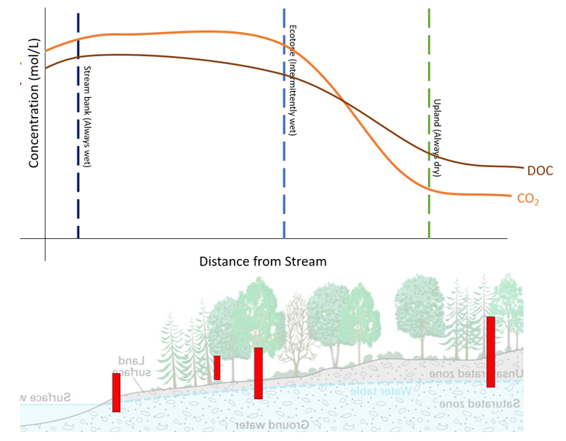
- FIGURE 2. Visual aid for hypothesis 1. Red rectangles are proposed well locations, and the above line graph hypothesizes DOC and CO2 concentrations within each well’s zone. Due to the river corridor’s (RC) tremendous carbon storage potential, as water moves laterally towards the stream, the concentration of C increases before discharging to the stream.

Methods:
Study Site:
An ecosystem garnering increasing interest for its capacity to store carbon is the flatwoods of North Florida. Due to the flatwoods confined aquifer and dense wetland-area, deep groundwater seepage is negligible, and the flux of carbon to streams is primarily driven by lateral transport via the shallow water table. As a result, North Florida’s flatwood landscapes exhibit unique modes of carbon transport that are largely disconnected from deep groundwater upwelling. This hydrology fosters carbon storage and creates a transport network through which nutrients and particulates flow laterally downhill before ultimately discharging into tannic, blackwater streams, emphasizing the importance of the river corridor (RC).
- For this chapter, I will observe three river corridors (RCs) from three streams (Stream: 5, 6, and 9) within the Bradford Experimental Forest (BEF), a contiguous pine flatwood situated above confining clay bed (Hawthorne Formation. Each of these streams belong to three distinct basins, each representing a gradient of wetland coverage (Ref. map).
Sampling and Sensor Readings:
- Along with the high-frequency, long-term sensor packages from Chapter 1, groundwater wells will be strategically installed across each streams river corridor (RC).
- RC wells will be deployed along the RC’s elevation gradient (stream bank, upland, and in-between) and in any significant micro-landscapes (intermittent flow paths and depressions, if present).
- Each well will be installed during the dry season to ensure the shallow water table can be reached even when the stream bed is dry, ensuring at least one well from each site has a viable volume of water present for sampling.
- Prior to sampling, at least triple the volume of the well water will be removed. If well water is exhausted during this process, the well will be deemed dry.

- During each monthly field visit, a roving pH (HOBO) and CO2 sensor (K30 10%) will take point readings of well water quality. Additionally, water table depth will be measured using a water level meter (NAME).
- Well water will be excavated using a peristaltic pump, filtered with filter capsule, and collected for DIC, DOC, and fluorescent dissolved organic matter (FDOM).
- During wet periods when intermittent flows paths and micro-wetland depressions are present, FDOM, DIC, and DOC samples will be taken from these pools since the surficial aquifers are depth is surface level.

Sample Processing:
- Both DIC and DOC analysis will follow methods outlined in Chapter 1.
- For quality control, DIC will also be interpolated using the pH, temperature, and CO2 point readings, and select samples will be periodically analyzed for alkalinity.
- FDOM samples will be analyzed following the protocols outlined in Chapter 1. FDOM results will infer how carbon quality changes as it travels across the river corridor.
- The pH sensor will be calibrated prior to each field day and all sampling equipment (syringes, vials, and bottles) were acid washed.

Discharge Estimates
- The estimation of RC lateral discharge will use methods adapted from Kirk and Cohen (2020) and involves applying concepts and techniques from Kalbus et al. (2016) and Leopold & Maddock (1953).
- This approach utilizes mass balance principles to divide the stream’s discharge into baseflow and high discharge (surface run-off). Digital elevation model (DEM) data will be utilized to estimate the upslope contributing area (UCA), the area of land that contributes water to the site’s discharge, for each site. The interpolation of lateral discharge is achieved by multiplying the UCA by the baseflow, known as q_{UCA}.
Data synthesis
- Pairing water quality data from the Water Quality Portal (WQP), and DEM data from the USGS National Map, in addition to the 9 streams in BEF, I will select ~5 streams from confined and unconfined aquifer units to investigate RC carbon contributions across watersheds.
- Assuming carbon concentrations are proportional to stream discharge and
applying methods summarized in Discharge Estimates, q_{UCA} is the volume of discharge generated by the surficial aquifer.
- Therefore, the difference between total discharge (Q) and q_{UCA} is the proportion of discharge supplied by groundwater (Q- q_{UCA}= q_{gw}). Assuming carbon concentrations are proportional to stream discharge, and removing carbon sourced from internal respiration, using q_{UCA}:Q and q_{gw}:Q stream carbon can be parsed into RC carbon and groundwater seepage.
Workflow:
- Screen the WQP for hourly DO, CO2, DOC, TOC, DIC and discharge data. In the absence of adequate carbon data, I will also screen for pH and temperature to interpolate either CO2 or DIC
  - I will interrogate sites from Appling et al. 2020 (streams that have ER modeled) to see if there is corresponding carbon data available.
- Selected WQP data will be paired with available DEMs from the USGS National Mapper.
- Interpolate UCA using methods from Kirk and Cohen 2020, and filtering techniques from Kalbus et al. (2016) and Leopold & Maddock (1953).
- Solve for q_{UCA} and q_{gw}.
- Parse carbon sources using q_{UCA}:Q and q_{gw}:Q ratios
Statistical Analysis
- (1) that the RC delivers most of the stream carbon and serves as a significant
  - To test hypothesis 1, the RC delivers majority of stream carbon, respiration-derived CO2 from Chapter 1 and estimated carbon from the RC will be subtracted from total stream carbon. The remainder will be “other,” assumed to be sourced from groundwater seepage and overland flow.
  - Carbon proportions sourced from respiration, the RC, and “other” will be compared over time and across basins.
- (2) RCs within basins with greater wetland area will exhibit greater carbon-storage potential due to their raised water tables supporting lateral, subsurface transport.
  - For hypothesis 2, basins with greater wetland area will larger RC exports, a linear regression model will be utilized to compare changes in RC fluxes with increasing basin-wetland coverage.
- (3) that RC carbon fluxes will be greatest during high discharge periods when the surficial aquifer is shallowest.
  - Similarly to assess whether RC carbon contributions vary water table depths and stream discharge (H3), linear regression analysis between carbon concentrations, water table depth and stream discharge will be employed.
  - To assess carbon quality as it travels through the RC, the humic index and fluorescence index from the FDOM analysis will correspond to the wells distance to the river, allowing a linear regression to evaluate the RC’s biogeochemical influence.
- (4) watersheds with a shallow surficial aquifer will have greater RC carbon contributions, supporting my overarching hypothesis that landscape hydrology has a significant influence on temporal stream carbon.
- Lastly, to test whether RC contributions significantly differ between confined and unconfined basins, analysis of variance (ANOVA) tests will be conducted.
  - ANOVA tests will allow for the comparison of mean carbon stream contributions between confined and unconfined basins, as well as between RC contributions and wetland contributions, providing insights into the relative importance of RC compared to wetlands in carbon budgeting.

- By employing these statistical analyses, the study aims to interrogate the factors influencing RC carbon-stream contributions and assess their significance in comparison to wetland contributions, expanding the of C dynamics within the study area.
FIGURE 3. A map depicting site locations and the surrounding landscape. The Bradford Forest tract, spanning 27,000 acres in Bradford County, Florida, encompasses a contiguous pine flatwoods landscape situated within the Hawthorne Formation. Characterized by low-relief topography, the area is densely packed with depressional basin wetlands, typical of North Florida flatwoods.

